Chapter 11, Problem 75.

Consider the power system shown in Fig. 11.90. Calculate:
(a) the total complex power
(b) the power factor
(c) the capacitance necessary to establish a unity power factor
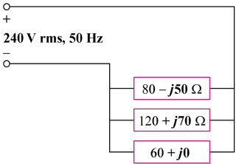

Ω

Figure 11.90
For Prob. 11.75.

